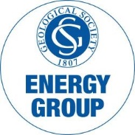
The Energy Group
Early Career Energy Geoscientist Award Nomination

The Award:
The Early Career Energy Geoscientist Award is an annual award presented to recognise Energy Geoscientists in the early stages of their career. Nominees must be within ten years (full time equivalent) of the award of their first degree in geoscience or a cognate subject, and either have already made a significant contribution to the understanding of Energy geoscience or be an emerging talent who is making a significant impact in the field. The winner will be presented with the award at the Energy Group annual dinner 2024.

Nominee:
…………………………………………….
Proposed By: (please add name in BLOCK CAPITALS after signature)
…………………………………………….
Supported By: (please add name in BLOCK CAPITALS after signature)
…………………………………………….
Supporting Statement:
Please supply a supporting statement of up to 200 words outlining the specific contribution of the individual and attach a copy of the nominee’s CV.

